MATIČNA PLOŠČA

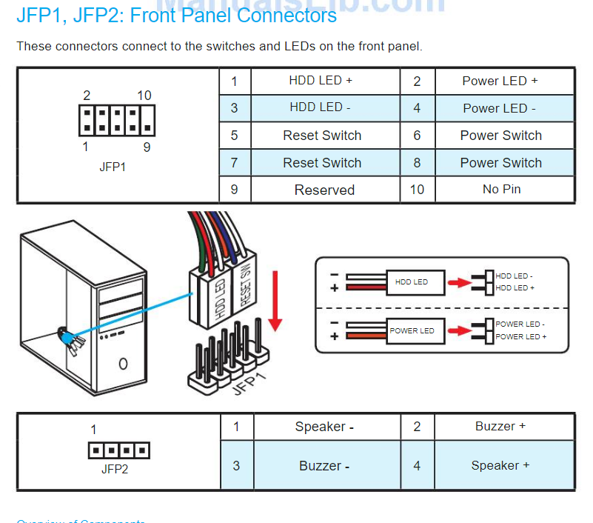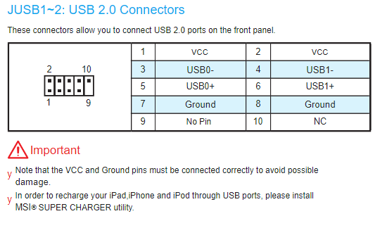
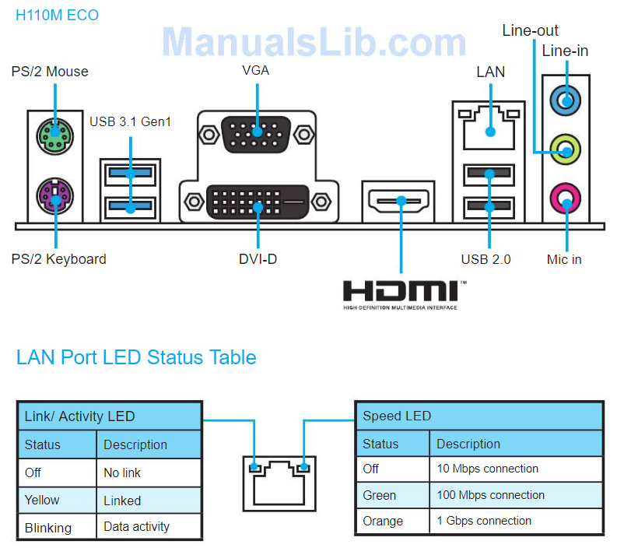

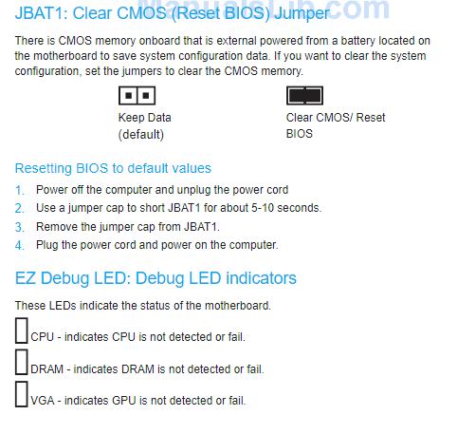

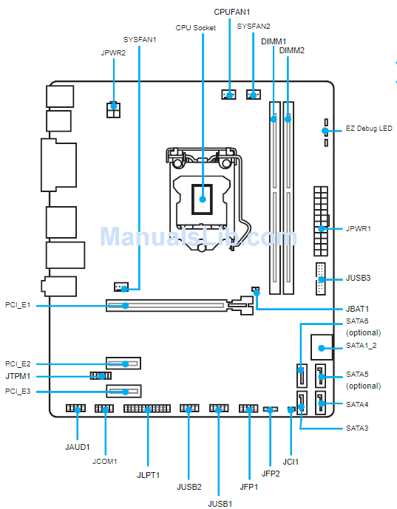
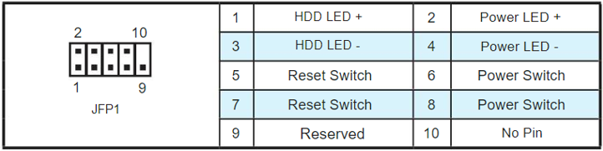

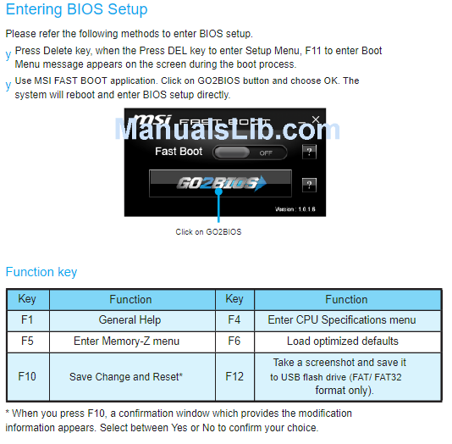

UTP KONEKTOR

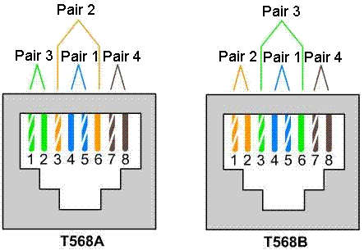

DOLŽINA 1cm

ROUTER
User manual
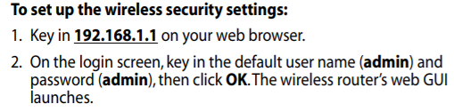
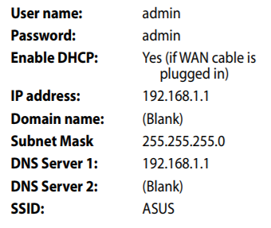

PROGRAMI
Chrome: https://www.google.com/chrome/
Mozila: https://www.mozilla.org/sl/firefox/new/
Opera: https://www.opera.com/download
Winrar: https://www.win-rar.com/download.html?&L=0

